**Software Testing Assignment**

**Module-4 Automation Core Testing**

**(Load Runner Up and Selenium IDE)**

* 1. **Which components have you used in Load Runner?**
* LoadRunner consists of three main components: Virtual User Generator (VuGen), Controller, and Analysis.

### VUGen

VUGen or Virtual User Generator is an IDE (Integrated Development Environment) or a rich coding editor. VUGen is used to replicate System Under Load (SUL) behavior. VUGen provides a “recording” feature which records communication to and from client and Server in form of a coded script – also called VUser script.

### Controller

Once a VUser script is finalized, Controller is one of the main LoadRunner components which controls the Load simulation by managing, for example:

* How many VUsers to simulate against each business process or VUser Group
* Behavior of VUsers (ramp up, ramp down, simultaneous or concurrent nature etc.)
* Nature of Load scenario e.g. Real Life or Goal Oriented or verifying SLA
* Which injectors to use, how many VUsers against each injector
* Collate results periodically
* IP Spoofing
* Error reporting
* Transaction reporting etc.

### Analysis

Once Load scenarios have been executed, the role of “**Analysis**” components of LoadRunner comes in.

During the execution, Controller creates a dump of results in raw form & contains information like, which version of LoadRunner created this results dump and what were configurations.

All the errors and exceptions are logged in a Microsoft access database, named, output.mdb. The “Analysis” component reads this database file to perform various types of analysis and generates graphs.

* 1. **How can you set the number of Vusers in Load Runner?**

Actual Test:

1. Run the actual test with a full load.
2. Collate the result after test completion.
3. Open the result file in the LoadRunner Analysis Tool.
4. Open the “Connections” graph. Graphs->Add New Item->Add New Graph->Web Resources->Connections.
5. Hover the mouse on the graph and get the “Number of Connections” value.
   1. **What is Correlation?**

Correlation in LoadRunner is a critical process that ensures the smooth execution of scripts during load testing. It handles the dynamic nature of client-server communication, making scripts more robust and reliable.

* 1. **What is the process for developing a Vuser Script?**

A vuser script may be created in four steps.

Step 1- Record the Vuser Script.

Step 2- Playback and improve the recorded vuser script.

Step 3- Define and test the different run-time parameters.

Step 4- Use the script in a LoadRunner scenario.

* 1. **How Load Runner interacts with the application?**
* Load Runner simulates user activity by generating messages between application components or by simulating interactions with the user interface such as keypresses or mouse movements.
* LoadRunner monitors network and server resources to help improve performance. LoadRunner also monitors issues like Network or client latency, CPU performance, I/O latency, server issues.
* LoadRunner automatically records the performance of client/server systems during testing.
  1. **How many VUsers are required for load testing?**

Concurrent virtual user calculation  
For example, if you run a load test with 10,000 virtual users, each making a request every 20 seconds (3 requests per minute), then you're making 30,000 requests per minute, which equals 500 requests per second.

* 1. **What is the relationship between Response Time and Throughput?**

Response time and throughput are related. The response time for an average transaction tends to decrease as you increase overall throughput. However, you can decrease the response time for a specific query, at the expense of overall throughput, by allocating a disproportionate number of resources to that query.

* 1. **To test the Performance testing on “Tops Technologies website”**
* https://[www.saucedemo.com/](http://www.saucedemo.com/)
  1. to Record all top level menu
  2. to Record minimum 10 Vuser on this website
  3. save all (Script,Design,Graph)
  4. **create a normal script of above website with correlate using hp default website.**

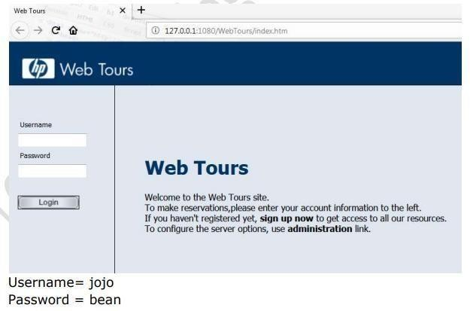

* 1. **What is Automation Testing?**
* Automated testing is a software testing technique that automates the process of validating the functionality of software and ensures it meets requirements before being released into production.
* With automated testing, an organization can run specific software tests at a faster pace without human testers.
* "Automation testing refers to the automatic testing of the software in which developer or tester write the test script once with the help of testing tools and framework and run it on the software. The test script automatically tests the software without human intervention and shows the result.”
* Automation testing needs manual effort when creating initial scripts, and further process is performed automatically to compare the actual testing result with expected results. This can be performed at these levels a) unit-level automation, b) API testing c) user interface.
  1. **Which Are the Browsers Supported by Selenium Ide?**
* Currently, Firefox, Chrome, Edge, IE, and Safari are supported by Selenium IDE.
  1. **What are the benefits of Automation Testing?**

## Advantages of automation testing are as below:

1. It saves time and cost in testing and provides an increment in the efficiency of testing.
2. Automation testing improves the accuracy of testing
3. With automation, more cycles can be achieved
4. It also ensures consistency in testing
5. It is testing scripts can be reusable
6. Ability to cover the test application features widely
7. Automation testing results are reliable
8. In this testing, human intervention is not required
9. Speedily executes the testing process frequently and thoroughly
   1. **What are the advantages of Selenium?**

## The benefits of using Selenium as an automation testing tool are listed below –

1. It is open-source and comes free without licensing cost.
2. It can used be used with more than one programming languages like C#, Java, Python, JavaScript, and so on.
3. It can be used in more than one platform like Windows, Mac, Linux, and so on.
4. It can be used for testing an application in more than one browser like Chrome, Firefox, IE, Safari, and so on.
5. It has a big community assistance for resolving users' queries.
6. It can support record and playback features with the help of Selenium IDE.
7. It can reduce use of resources and time consumption by executing tests in headless mode.
8. It can execute tests in more than one operating system and browsers simultaneously by dispersing tests in multiple machines with the help of Selenium Grid.
9. It can be integrated easily with various test management, reporting, build and continuous integration tools, third party APIs and test frameworks.
10. It can be used for testing multiple devices like Blackberry, iPhones, Android.
11. It has easy and friendly APIs.
12. It supports simulation of mouse and keyboard actions.
13. It comprises various test tools – Selenium Grid, Selenium IDE, and Selenium RC, hence often called as a suite. Each of these tools are used for a specific purpose.
14. It is flexible since it can be used with multiple frameworks like TestNG, JUnit and so on.
15. It gives reusability of tests since the same tests developed can be validated against multiple browsers.
16. It can be used for a wide range of testing which includes functional, regression, end-to-end, cross browser, smoke, sanity, acceptance, integration, and so on.
    1. **Why testers should opt for Selenium and not QTP?**

* Selenium is an open-source test automation framework that can automate web applications. It is a popular choice for testers because it is free to use and supports many programming languages, including Java, Python, Ruby, and C#. Selenium allows scripting as well as record-and-playback via selenium IDE.
* While QTP only supports the VBScript programming language. Test scripts cannot be written in any other language. Also QTP test scripts run only on the Windows environment. They cannot be run across all browsers.
  1. **To validate the Swag lab website Login and logout process page** https://[www.saucedemo.com](http://www.saucedemo.com/)